Excel Assignment – 6

1. What are the various elements of the Excel interface? Describe how

they're used.

|  |  |
| --- | --- |
| **Interface Element** | **Description** |
| Ribbon Tabs | Ribbon Tab is a tab that organizes commands by topic |
| The Ribbon | Commands underneath the Tabs |
| Ribbon Groups | Grouping of related commands |
| Dialog Box Launcher | Opens a dialog box that includes additional commands |
| Quick Access Toolbar | One click accesses to any frequently used command |
| Name Box | Displays cell location and can be used to navigate to a cell location |
| Select All Button | Selects all the cells in a worksheet |
| Formula Bar | View, enter, or edit cell contents |
| Insert Function Button | Displays Insert Function dialog box |
| Scroll Bars | Used to navigate up, down, left & right |
| Zoom Slider | Zoom into an area of the worksheet |
| View Buttons | Switch between Normal, Page Layout and Page Break Preview views |
| Worksheet tabs | Tabs used to select individual worksheets |
| The Workspace | The area inside of the columns and rows used in Excel |
| Columns | Columns use letters |
| Rows | Rows use numbers |

Answer:

1. Write down the various applications of Excel in the industry.

Answer: Excel. Chances are, that word alone inspires visions of lengthy spreadsheets, complicated macros, and the occasional pivot table or bar graph. It’s true—with more than one billion Microsoft Office users globally, Excel has become the professional standard in offices across the globe for pretty much anything that requires management of large amounts of data. But, if you think Excel is only good for making you cross-eyed while looking at a bunch of numbers and financial reports, think again. As Tomasz Tengiz points out, there are tons of uses of Excel in business (and beyond) outside of simple spreadsheets. In fact, the potential uses are seemingly endless. There’s no way for us to compile a list that captures every one of Excel’s possible applications (even if you were up for reading a War and Peace-sized listicle). However, in an effort to demonstrate the power and flexibility of everybody’s favourite spreadsheet tool, we’ve pulled together different ways that you could use Excel—both professionally, personally, and just for the fun of it.

* Calculating
* Accounting
* Charting
* Inventory tracking
* Calendars and schedules
* Goal planning worksheet
* Task list
* Project management charts
* Mailing list

1. On the ribbon, make a new tab. Add some different groups, insert

commands in the groups and name them according to their commands

added. Copy and paste the screenshot of the steps you followed.

Answer:

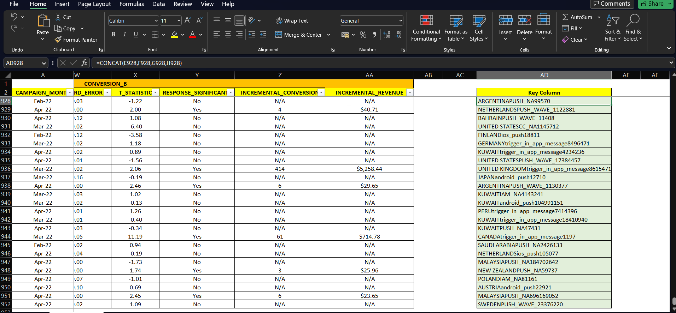

1. Make a list of different shortcut keys that are only connected to

formatting with their functions.

Answer: Shortcut Keys and their Functions: Some commonly used computer short cut keys are documented below.

Short-cut Keys and their Descriptions

* Alt + F: File menu options in current program.
* Alt + E: Edit options in current program
* F1: Universal Help in almost every Windows program.
* Ctrl + A: Select all text.
* Ctrl + X: Cut
* Shift + Del: Cut selected item.
* Ctrl + C: Copy selected item.
* Ctrl + Ins: Copy selected item.
* Ctrl + V: Paste selected item.
* Shift + Ins: Paste.
* Home: Goes to beginning of current line.
* Ctrl + Home: Goes to beginning of document.
* End: Goes to end of current line.
* Ctrl + End: Goes to end of document.
* Shift + Home: Highlights from current position to beginning of line.
* Shift + End: Highlights from current position to end of line.
* Ctrl + Left arrow: Moves one word to the left at a time.
* Ctrl + Right arrow: Moves one word to the right at a time.
* Shortcut Keys and their Functions: Below is a listing of all the major shortcut keys in Microsoft Word.
* Shortcut Keys and their Descriptions
* Ctrl + A: Select all contents of the page.
* Ctrl + B: Bold highlighted selection.
* Ctrl + C: Copy selected text.
* Ctrl + X: Cut selected text.
* Ctrl + P: Open the print window.
* Ctrl + F: Open find box.
* Ctrl + I: Italic highlighted selection.
* Ctrl + K: Insert link (Shortcut Keys and their Functions).
* Ctrl + U: Underline highlighted selection.
* Ctrl + V: Paste.
* Ctrl + Y: Redo the last action performed.
* Ctrl + Z: Undo last action.
* Ctrl + L: Aligns the line or selected text to the left of the screen.
* Ctrl + E: Aligns the line or selected text to the center of the screen.
* Ctrl + R: Aligns the line or selected text to the right of the screen.

1. What distinguishes Excel from other analytical tools?

Answer: The excel spreadsheet displays financial information in an organized manner. The information could be related to the sales, management department, HR or the marketing. Most of the businesses are dependent on IT sector and therefore excel is a vital tool to run a business. Read on to learn about the topmost features of this software.

* It builds the charts
* It makes use of conditional formatting
* It helps to organize the data
* It will identify trends
* It provides online access

Excel will use range of formulas to unlock the potential of data. You have to insert data in individual cells of columns and rows. In this way, data will be filtered and sorted and hence displayed in a presentable manner. Different types of charts like clustered columns, graphs and pie chart provide great visual presentation. It puts more emphasis to marketing material and business reports. Excel is a wonderful tool to represent data on X and Y axis.

1. Create a table and add a custom header and footer to your table.

